Screenwave has tickets onsale for two concurrent events: Screenwave’s Vive la France French Film Festival and SWIFF Film Club membership.
Please select from the tabs at www.swiff.com.au for which or both you would like tickets to attend.
Once booking has been confirmed, you will receive an email with your receipt including membership number (SWIFF Film Club) or tickets (Vive la France).
SWIFF Film Club members will also receive a membership card to be collected at the next film club screening.
You need a dedicated email address to purchase SWIFF Film Club memberships. Up to two memberships can be purchased using one account/email address.

HOW TO PURCHASE SWIFF FILM CLUB MEMBERSHIP

- Go to WWW.SWIFF.COM.AU and select FILM CLUB from tab

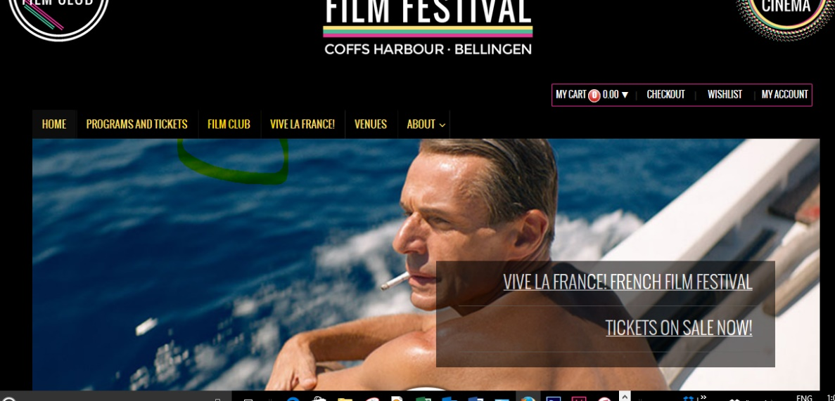

- Select BUY MEMBERSHIP

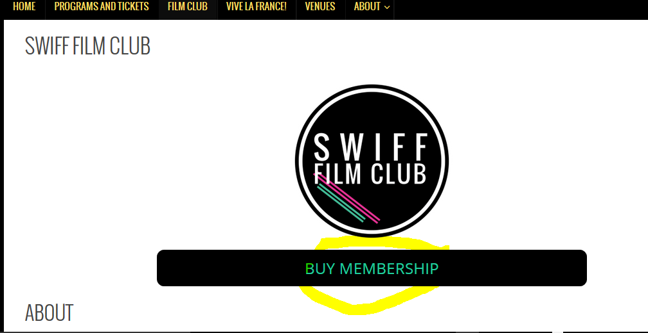

- Select New Membership > Add to Cart
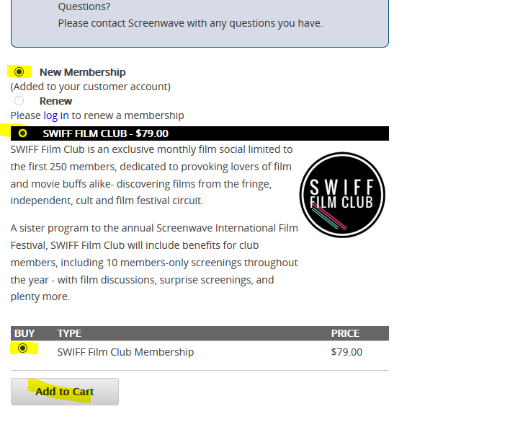

- Select CHECKOUT
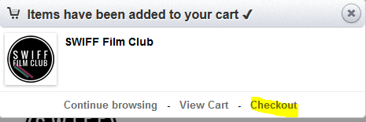

- Login or Create a New Account
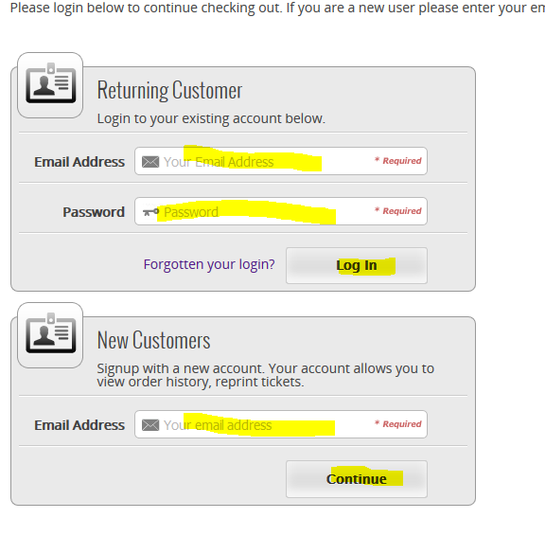

- Add Payment Details > Confirm booking
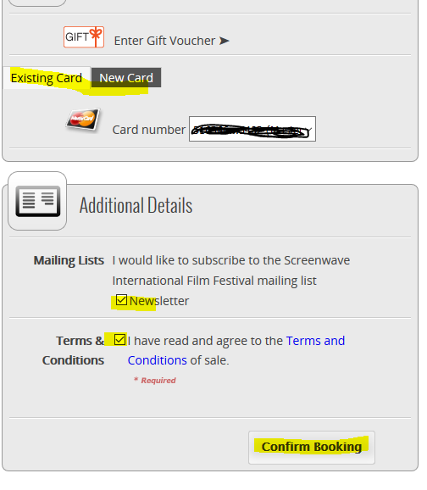

Once booking is confirmed you will receive an email with a receipt that includes your 7-Digit membership number 15XXXXX. You can use this number to redeem tickets to Vive la France and upcoming Screenwave International Film Festival.

SWIFF Film Club members will receive a membership card at the next screening.

